

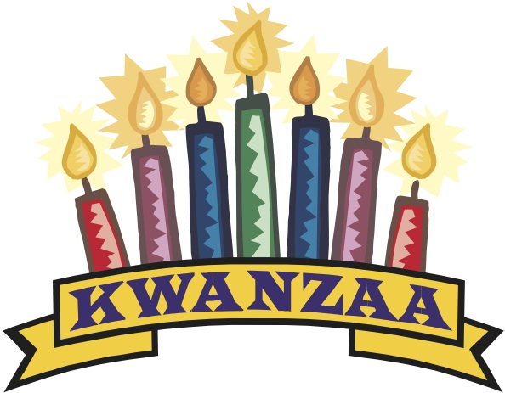
Delta Kappa Gamma
Annual Holiday Auction

Tuesday, December 3rd, 2013
3:30 P.M. Social/4:15 P.M. Auction
Prince of Peace Church
930 W. Higgins Road
Schaumburg, IL 60194

Please mark your calendars and join us as we come together to celebrate the season AND raise money to fund our scholarships!

Your donations and purchases support the Annual Grant-in-Aid as well as stipends for past recipients now in college. Please bring one or more items to auction and plenty of money to buy those brought by fellow members. If possible, email a description of the item you are bringing and a suggested starting bid to maureen3143@comcast.net. This information greatly helps the auctioneers. Elves on the Shelves and the popular 50/50 will return. Gift Baskets will be graciously accepted and highlighted. And, of course, there is the lively Live Auction run by our talented elves!

Information about dinner will be sent separately by our hostesses.

Remember that friends, former, and prospective members are welcome!

Current Chapter Newsletter

The Gamma Gamma Ray
Newsletter of
Gamma Gamma Chapter
Lambda State Organization,
The Delta Kappa Gamma Society International

November – December 2013

Dates to Remember:
Tuesday, December 3rd: Holiday Auction: “Shop ‘Til You Drop”
Saturday, January 25th: Feed My Starving Children
Monday, February 10th: Grimm’s Grimmest: The Darker Side of Fairy Tales
Location: Prince of Peace
Monday, March 10th: Conversation/Game Night for Read to Learn
Churchill Elementary School
(PLEASE NOTE THE FEBRUARY AND MARCH DATES AND LOCATIONS)

AUCTION – AUCTION – AUCTION TIME!

DATE: TUESDAY, DECEMBER 3RD
TIME: 2:00 – 3:30 SET-UP
3:30 – 4:00 SOCIAL
4:00 AUCTION
LOCATION: PRINCE OF PEACE CHURCH
930 W HIGGINS ROAD
SCHAUMBURG, IL 60194 847.885.7010
SERVICE PROJECT: FUNDRAISER FOR RECRUITMEMT GRANT

Arrangements: Glenda Klein-Mali
Hostesses: Society Business Committee: *Charlotte Weber, Kris Beaudette,
Felicia Cichy, Nanette Doubler, Joan Gazdic, Mary Guthrie, Mary
Marowally, Judy Nimmo, Adrienne Rovin, Sally Scholler, Kathleen
Stephansen, Linda Stolt
Communications/Publicity: *Barbara Peterson, Dorothy Clair, Geri
DeFalco, Carol Escorcia, Jan Kayson, Cheryl Keifer, Kathy Muench,
Patricia Rielly, Julie Rowe, Mary Salee, Jane Kennedy-Smith

Reflection: Charlotte Weber

Contacts: Glenda Klein-Mali 847.519.3933
Maureen Briza 630.845.4088

Thanking everyone in advance – so many helping hands – who will make this event such a success!

ANOTHER AWESOME DATE TO SAVE

***Feed My Starving Children***
SATURDAY, JANUARY 25TH, 9:00 – 11:30 AM

A “Message” from Anne Fussell, our Special Projects Chair, who has always done a fantastic job of arranging this event:

Sign-up sheets will be available at the December meeting or you can email me at fva936@aol.com. Family members and friends are welcome to join us. I had an email the other day that they will be sending food packs to the Philippines so this would be a great way to help out in that effort, too!
Don’t forget to be adding to your FMSC carry-out container to help pay to ship the food we pack. You can return these at the December meeting or bring them to the January pack session. If you prefer to write a check so you can take it off your taxes,
please make it out to FMSC. (If you were not at our wonderful October meeting to get a container, I will have them at the December meeting.)
We will be going to Jason’s Deli for lunch after the session if you care to join us.
Thanks for your support!
Anne

Another note:
It looks like the LEGISLATURE is going to try to pass some kind of pension bill during the first week of December. Madigan has told members to keep December 2nd and 3rd open. Please be ready to make those phone calls and send those emails!
More information as soon as we have it!
Thanks so much for all your help on this seemingly never-ending battle!
Anne

Past Evening Social Gathering

A “Thank You” goes to Glenda, who arranged our “Saturday Evening at the Puppet Opera”. “The uniquely articulated rod puppets used in the presentation of Opera in Focus – the only ones of their kind in the world….” truly provided an exceptional evening of entertainment.

November Book Review:
No Reservations Required
Author: Ellen Hart
Reviewer: Keri Gold

I consider myself a connoisseur of the food mystery genre. Over the years I’ve read them all: donut shop mysteries, coffee house mysteries, cheese shop mysteries and farmers’ market mysteries. Many follow a predictable pattern and are “light reads”; therefore, I was pleasantly surprised by the meatiness of this book. I knew I was in for a treat when I opened the book to find a cast of characters. This book did not disappoint. Three murders were deliciously intertwined to form a compelling story line of mystery and plot twists. While this book did not yield the numerous recipes like others in this genre, the connections to food in the plot where evident throughout. As this is the first book I have read by this author, I am looking forward to reading other titles in this series.

NTETP – Never To Early To Plan
The Holidays come and go quickly – believe it or not – so never to early to plan our attendance at the Lambda State Convention in St Louis, from April 25th-27th. Let’s get some friends together and head downstate for a women’s weekend of fun, entertainment and information – though primarily FUN!

The Lambda State Technology Seminar will be held at Bradley University, and the tentative dates are June 24th - 25th, 2014. This is an economical way to gain more technological skills and insights.

Race to Indianapolis for the 2014 International Convention, July 28th to August 1st. At the opening of the Convention, Sarah Sladek, author of “The End of Membership As We Know It”, will reflect on effective steps in attracting and retaining multigenerational members. Certainly a topic that interests all of us, as we continue to strive to initiate new members, while retaining our treasured members. Gammma Gamma ranks 6th in MEMBERSHIP (at 82) in Illinois’ Delta Kappa Gamma Society. Let’s keep that number growing!
If anyone would like to present a workshop at the 2014 International Convention, proposal submission deadline is January 3rd, 2014. One could really gain tremendous insight into our international organization.

Dues Update
Another year, another year’s dues collected! I wish to thank both Linda Stolt and Jane Martin, who have worked to collect all the membership dues, and who both have reached out to connect with members who were delayed in turning in their dues. And THANK YOU to most all members, who quickly turned in their dues!

Jane’s Jottings

As I have previously mentioned in this Newsletter, I have always said to my District 54 teams members that “Holiday Time” just flies by. AND: Once we come back from the break, it’s almost Spring “Time”, then it’s almost Summer vacation “Time”! “Time” has a habit of moving along quickly – too quickly. I still have no idea what happened to September and October. Dear Sisters, enjoy this special season, the “best time of the year”. Remember to bring your pocketbook to the Auction and spend like there is no TOMORROW!

Cheers, President Jane

